**Experiment-7 Understanding Router and Hub**

ECP316 (Communication Networks)

**Aim:** Understanding the difference between a Switch and a Hub.

**Tools Used:** Cisco Packet Tracer

**Theory:**

In computer networks, a hub is a basic networking device that connects multiple computers or network devices together in a Local Area Network (LAN). It operates at the physical layer (Layer 1) of the OSI model and broadcasts data it receives to all connected devices, regardless of the intended recipient.

A switch in computer networks is a more advanced device than a hub, used to connect multiple devices within a Local Area Network (LAN). It operates at the data link layer (Layer 2) of the OSI model.

**Procedure:**

1. Open Cisco Packet Tracer application on computer.
2. Use Set of PCs one under Router and another under Hub.
3. Use PT Hub and Switch only as they’re already defined according to our use.
4. Use RJ45 Cables to connect the PCs and switches as according to the topology diagram. We can check the connections using ping in the command prompt of each PC.
5. Try sending mail from one PC to another in both cases and start simulation and observe.
6. Try Sending on different paths like 1st router sub-PC to 2nd router sub-PC etc..

**Connections:**

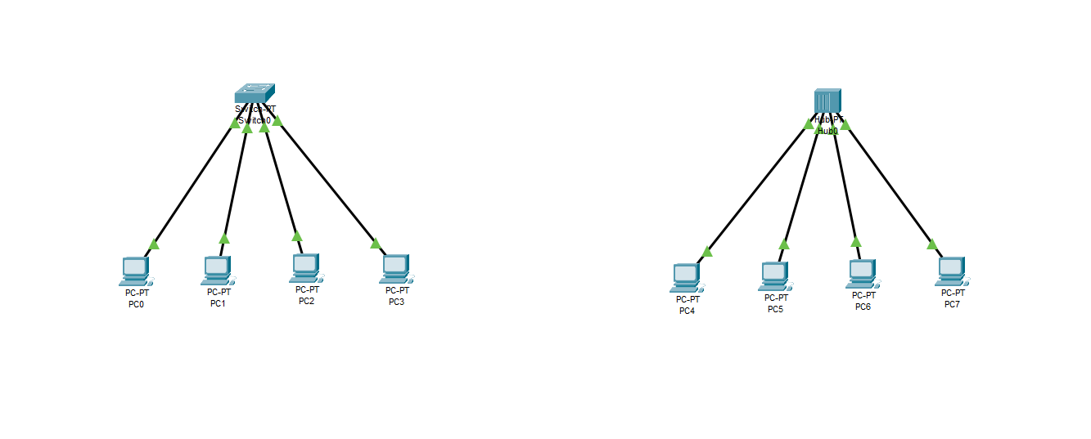

**Testing on Routes (Simulation):**

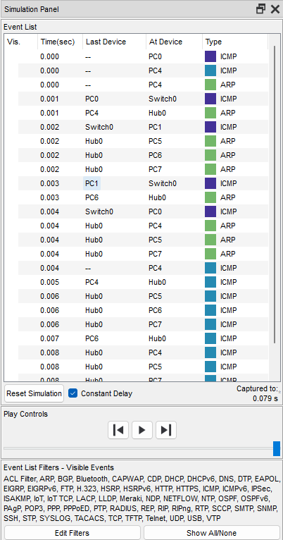

**Success:**



**Sending Simultaneously in Switch Network:**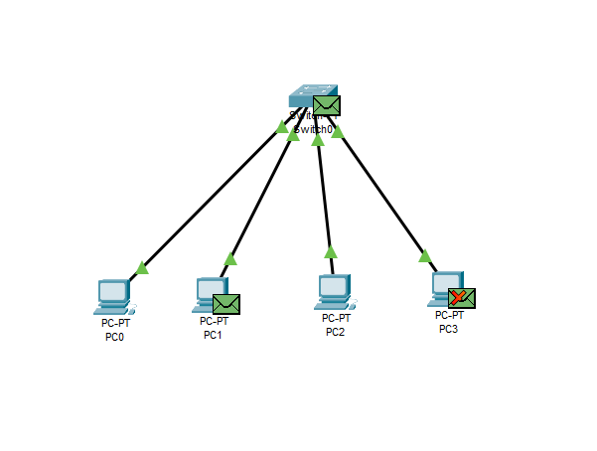



**Collision in Hub Network in Simultaneous Sending:**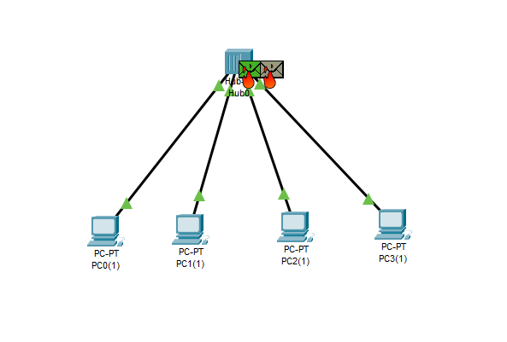

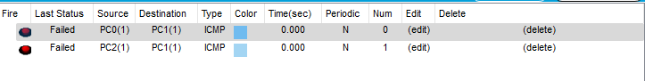

**Result:**

In the Cisco Packet Tracer experiment, the switch efficiently forwarded data **only to the intended recipient** using MAC address learning, reducing network congestion.

In contrast, the hub broadcasted data **to** **all connected devices**, leading to collisions and inefficiencies. The switch demonstrated superior performance, enhancing network speed and reducing unnecessary traffic.

**Conclusion:** The experiment demonstrated that switches are more efficient than hubs in network communication.

Switches use MAC address learning to forward data only to the intended device, reducing collisions and improving performance. Hubs, however, broadcast data to all devices, leading to congestion.

Thus, switches are preferred for modern network setups.